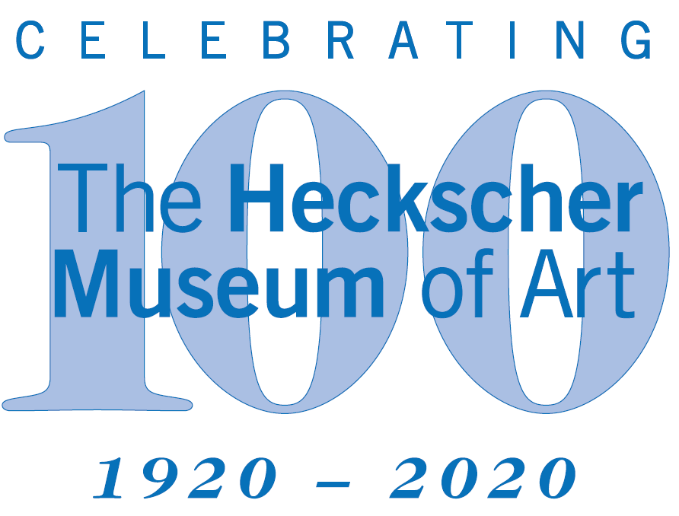

The Heckscher Museum of Art Contact
2 Prime Avenue, Huntington, NY 11743 Jill Rowen
631.351.3250 Rowen@Heckscher.org www.Heckscher.org 631.351.3006

FOR IMMEDIATE RELEASE
October 2019
The Heckscher Museum of Art Presents

Locally Sourced: Collecting Long Island Artists
On View November 23, 2019 to March 15, 2020

Huntington NY -- Locally Sourced: Collecting Long Island Artists tells the compelling story of art on Long Island through The Heckscher Museum’s Permanent Collection. Long Island art has been central to the strength of the Heckscher Collection. The exhibition underscores the Museum’s commitment to preserving and presenting the stories of Long Island through art, especially important as it embarks on its centennial year in 2020. The exhibition is on view November 23, 2019 through March 15, 2020.
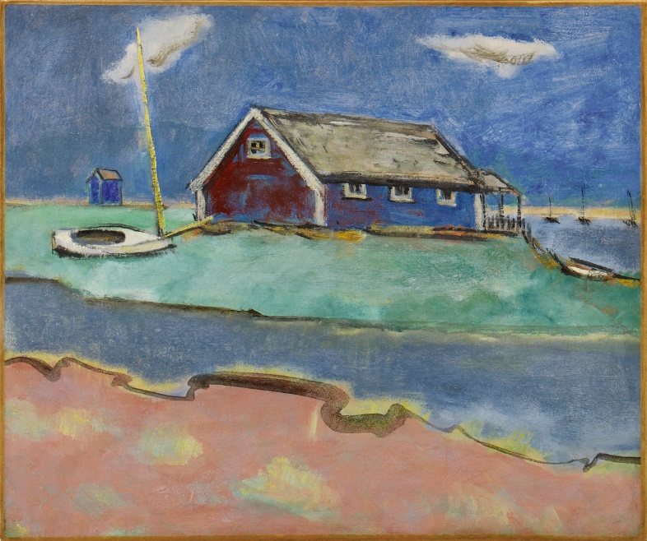
Organized in four distinct themes, the exhibition fills the entire Museum with painting, sculpture, photography, and mixed media work. The Long Island landscape is a central theme, and particular attention is paid to the achievements of women artists of Long Island.

One gallery is devoted to Huntington’s hometown artists spotlighting important figures including Stan Brodsky, Mary Callery, and Arthur Dove. Another traces formal, technical, and conceptual connections between artists of the East End such as Fairfield Porter and Jane Wilson. (Image right: Max Weber, White Beach House, 1942, oil on canvas)

Locally Sourced is Sponsored by
Robin T. Hadley
Andrea B. and Peter D. Klein

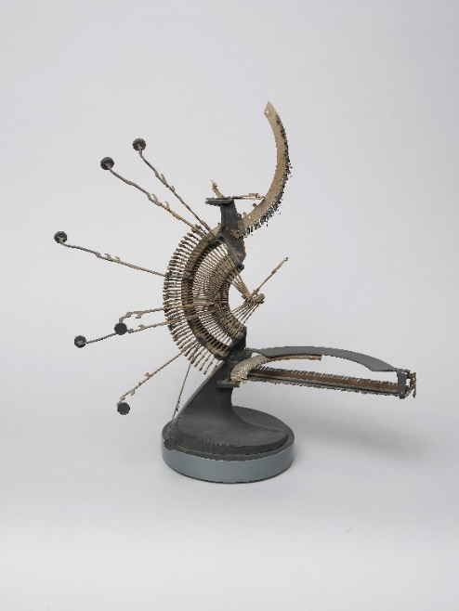
Landscapes predominate in a third gallery, whether captured through representation or evoked through abstraction. Spanning the nineteenth century to the present, the show invites consideration of varied approaches to Long Island’s land, sea, and sky in works by artists such as Thomas Moran, Ty Stroudsburg, and Max Weber.

In part to mark the 100th anniversary of women’s suffrage in America, the show also revels in the remarkable work of locally and internationally renowned artists Betty Parsons, Esphyr Slobodkina, and Miriam Schapiro, among others. (Image left: Esphyr Slobodkina, Typewriter Bird, 1960, mixed media construction)

The Museum’s Permanent Collection mirrors the commitment to Long Island’s rich artistic environment. The Museum plays a prominent role in the cultural life of Long Islanders, celebrating important art and artwork in the community. This exhibition explores the continuity as well as the changes across decades of Long Island art.

Visitors will also have fun with a large Long Island graphic in the Huntington gallery, where they will be able to share and comment on their Long Island favorites.

About The Heckscher Museum of Art
The Heckscher Museum of Art, founded in 1920 by philanthropist August Heckscher, is located in scenic Heckscher Park in Huntington, New York. Through its exhibitions and related programs, the Museum provides inspiring and transformative experiences to encourage a broader understanding of the past and present and to enrich life-long learning. The Museum’s collection comprises more than 2,500 works from the 16th to the 21st century, including European and American painting, sculpture, works on paper, and photography. For information about The Heckscher Museum of Art, visit Heckscher.org.

Museum Hours
Wednesday - Friday | 10:00 am - 5:00 pm *
Saturday and Sunday | 11:00 am - 5:00 pm *
Monday and Tuesday | Closed
Admission: $8 Adults; $6 Seniors; $5 Students; Children under 10 FREE
*Huntington Township Residents admitted FREE Wednesdays after 2:00 pm and Saturdays before 1:00 pm. Proof of residency required.

Free Admission for Active Military Personnel, Veterans, and Family
Available to any bearer of a Geneva Convention Common Access Card (CAC), a DD Form 1173, a DD Form 1173-1, a Veteran’s DD-214, or a Veteran ID card and a driver’s license. Includes active military personnel (Army, Navy, Air Force, Marines, Coast Guard, National Guard, and Reserve) or Veteran and up to five (5) family members (spouse, child, aunt, uncle, grandparent, etc.)

Accredited by the American Alliance of Museums (AAM) since 1972.

